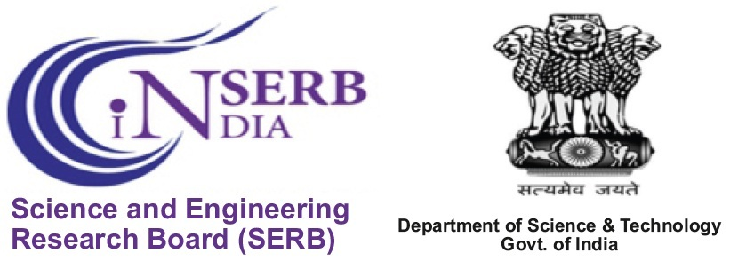

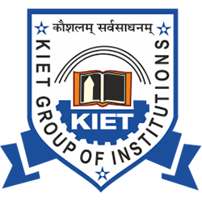

**INTERNATIONAL CONFERENCE**

**On**

***“Recent Trends and Innovations in Mechanical Engineering (ICRTIME 2018)”***

**Friday & Saturday  
20th & 21st July 2018**

# *Sponsored By*

***Science and Engineering Research Board (SERB),***

***Department of Science & Technology (DST)***

***Govt. of India***

**Registration Form**

1. **Name: ………………………………………………….………………………………..**
2. **Designation: ……………………………………………………………..………………………**
3. **Institute/ Organization: …………………………………………….………………………**
4. **Address for communication: …………………………………………………..………………**

**…………………………………………………………..…………………………………...…………………………………………………….………….……………………………………...…**

1. **Title of Paper: ……………………………………………………………………………**
2. **Details of Co- Authors (if any) …………………………………………………………………..**

**………………………………………………………………………………………………………**

1. **Mobile: ……………………………………………………………………………..……**
2. **E-mail:……………………………………………………..……………………………….……..**
3. **Payment Detail (Transaction No./Reference No.) …………………………………………**

**(Signature)**